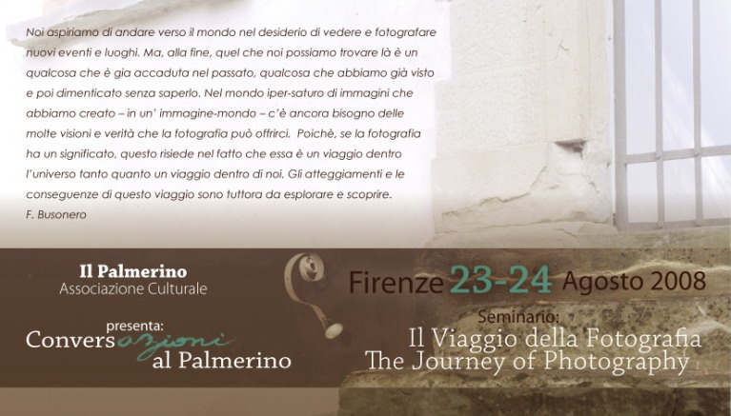

L’associazione Culturale
Il Palmerino
Presents

“Conversazioni al Palmerino”

The Journey of Photography
A conversation with Paul Fusco

August 23-24, 2008

Featuring:

Paul Fusco
Anne Sanciaud-Azanza
Giovanni Chiaramonte
Andrea Ulivi
Federico Busonero (Seminar Director)

Day 1 – Saturday, August 23, 2008

9.00–10.00am: Registration

10.00-10.15am: Welcome and Introduction by Seminar Director

10.15-11.45am: Bitter Fruit by Paul Fusco

11.45-12.00am: Break

12.00am- 1.00pm: Il libro, la parola, la fotografia / The book, the word, the photograph by Giovanni Chiaramonte and Andrea Ulivi

1.00pm-2:15pm: Buffet Lunch in Garden (included)

2:15-3.45pm: A history of travel photography: from a presumed objectivity to the affirmation of subjectivity by Anne Sanciaud-Azanza.

3.45-4.00pm: Coffee Break

4.00-5.30pm: La dimora dello sguardo by Giovanni Chiaramonte.

5.30-18.30pm: Session 1: One-on-One Meeting with Curator Anne Sanciaud-Azanza for a critical evaluation and discussion of personal photographic work by seminar registrants (appointment schedule announced at start of seminar)

18.30pm: End of Day 1

Evening activities: TBD (visit to Alinari Museum, evening walk to Fiesole, restaurant suggestions etc.)

-------

Day 2 – Sunday, August 24, 2008

9.00-9.15am: Greeting by Seminar Director

9.15-10.45am: Chernobyl Legacy by Paul Fusco

10.45-11.00am: Break

11.00am-12.30pm: R.F.K. Funeral Train by Paul Fusco

12:30-2.00pm: Buffet Lunch in Garden (included)

2:00-3.15pm: Vision and Interrogation: a dialogue between Poetry and Photography by Andrea Ulivi and Federico Busonero.

3.15-3.30pm: Coffee Break

3.30-17.00pm: The Journey of Photography/Il Viaggio della Fotografia – a discussion among the speakers: Paul Fusco, Anne Sanciaud-Azanza, Giovanni Chiaramonte, Andrea Ulivi e Federico Busonero.

17.00-17.15pm: Closing by Seminar Director

5.15-6.00pm: Session 2: One-on-One Meeting with Curator Anne Sanciaud-Azanza for a critical evaluation and discussion of personal photographic work by seminar registrants (appointment schedule announced at start of seminar)

6.00pm – End of Day 2

Il Palmerino Associazione Culturale
Via del Palmerino 6a
50137 Firenze
Italy

info@palmerino.it
www.palmerino.it/cantieridarte

Contact: Federica Parretti Tel. (+39) 339 8944725

******

Speakers:

Paul Fusco:

Paul Fusco is a worldwide known photographer and a member of the Magnum Photos Agency since 1974. He lives in New York City.

Bitter Fruit

Bitter Fruit is a moving and exceptional statement of the aftermath of the Iraq war in the United States. Since its beginning, Paul Fusco has traveled to more than 22 American towns to witness and record, in his own words, the “bitter truth and the intolerable loss of this war and its pain “. His vision and courage are poignant.

Chernobyl Legacy:

Chernobyl Legacy constitutes perhaps the greatest achievement of Paul Fusco. That journey had a profound effect on him. Beyond his masterful ability to document the unbearable abyss of the tragedy, we feel the great pain and humanity of the photographer. His cry of despair is the despair of each of us.

R.F.K. Funeral Train:

On the 40th anniversary of the death of Robert Kennedy, the photographs which Paul Fusco took in June 1968 are significant at this moment in time. They are a moving portrait of a nation. As such, they belong to the consciousness of all American people. The train carrying the coffin of Robert Kennedy took away their dream and their hope of a better life, but also provided them with a new courage - the affirmation of a common identity.

Anne-Sanciaud Azanza:

Dr. Anne Sanciaud-Azanza is Curator at the Bibliothèque municipale de Tours, and former Curator of Contemporary Photography at the Bibliothèque nationale de France.

Une histoire de la photographie de voyage : de la prétendue objectivité à une subjectivité assumée.

L'invention de la photographie a profondément modifié notre rapport au voyage. Dans un premier temps, l'image photographique a été considérée comme un document reproduisant le réel à l'identique, comme un moyen de voyager par procuration. Au XXe siècle, les photographes humanistes ont défendu l'idée que la photographie était un moyen de changer le monde et de le rendre meilleur. Après la deuxième guerre mondiale, chaque photographe a développé sa propre vision de la photographie de voyage : outil idéologique, voyage intérieur ou fascination pour des mondes lointains.

A history of travel photography: from a presumed objectivity to the affirmation of subjectivity.

The invention of photography has completely changed our vision of traveling. At the beginning, photography was considered as a document, a reproduction of reality, and people thought it was a way to travel without moving. In the twentieth century, humanist photographers began to think that photography was able to change the world and to make it better. After World War II, each photographer creates his own perception of travel photography: as a political tool, as an intimate dream or as a fascination with distant worlds.

Giovanni Chiaramonte

Giovanni Chiaramonte is the founder of “Punto e Virgola” (in association with Luigi Ghirri) and “Tutt’altro Fotografia“ (Edizioni della Meridiana). An influential figure in the world of contemporary Italian photography, his work has been widely recognized and published. Among his publications, Giardini e Paesaggi (1983), Penisola delle Figure (1933), Terra di Ritorno (1989), Westwards (1996), Dolce è la luce (2003), Come un Enigma (2006).

Andrea Ulivi and Giovanni Chiaramonte

Andrea Ulivi is the founder of the Publishing Press Edizioni della Meridiana, and Director of the International Institute Andrej Tarkovskij in Florence.

Il libro, la parola, la fotografia

Il libro come viaggio fra parole e immagini. Tutto il mondo del libro è costruito da un universo di parole e di immagini. La realtà del libro come la realtà del mondo. Il libro di fotografia permette il viaggio attraverso le visioni che l'occhio del fotografo è riuscito a cogliere. Allora il libro di fotografia diventa un percorso/viaggio i cui passi sono scanditi da attimi colti o attesi.

"Il mondo è un libro e coloro che non viaggiano ne leggono solo una pagina." (Agostino)

The book, the word, the photograph

The book can be seen as a journey between words and images. The entire world of books is constructed by a universe of words and images. The reality of the book reflects the reality of the world. The photo-book allows us a journey through the visions which the photographer’s eye succeeded to capture. As such, the photographic book becomes a path where steps are marked by those moments of time which we have been waiting for.

“The world is a book and those who do not travel can read only one page of it” (Augustin)

Andrea Ulivi and Federico Busonero:

Visione e interrogazione: un dialogo tra Poesia e Fotografia

Gli autori presentano una conversazione sulle affinità tra poesia e fotografia. Entrambe condividono la medesima necessità di una visione. Fotografia e poesia sono un’interrogazione, e una ricerca continua di nuove possibilità nell’affermazione del nostro essere nel mondo.

Vision and Interrogation: a dialogue between Poetry and Photography.

The authors present a conversation on the affinities which exist between photography and poetry. They share the same necessity of a vision. Photography and poetry are an interrogation, and a constant search for new possibilities in affirming our existence in the world.

Federico Busonero

Federico Busonero is the author of five photographic books. His work has been exhibited in France, Italy, Germany and United States. He lives between the Pacific Northwest and Italy.

The Journey of Photography:

We long to go into the world for the sake of seeing and photograph new events and places. Yet, in the end, what we may see there is something which has already occurred in the past, something which we have already seen and forgotten without knowing it. In a world of images – in an image-world – we still need the many visions and truths which photography can offer us. Because, if anything, photography is a journey into the world as much as a journey into us. The consequences of this journey are yet to be discovered.

Il Viaggio della Fotografia:

Noi aspiriamo di andare verso il mondo nel desiderio di vedere e fotografare nuovi eventi e luoghi. Ma, alla fine, quel che noi possiamo trovare là è un qualcosa che è già accaduto, sotto diversa forma, nel passato, qualcosa che abbiamo già visto e poi dimenticato senza saperlo. Nel mondo iper-saturo di immagini che abbiamo creato – in un’immagine-mondo – c’è ancora bisogno delle molte visioni e verità che la fotografia può offrirci. Poichè, se la fotografia ha un significato, questo risiede nel fatto che essa è un viaggio dentro il mondo tanto quanto un viaggio dentro di noi. Le conseguenze di questo viaggio sono tuttora da scoprire.

--------------------------

